**MANAV RACHNA UNIVERSITY**



**PYTHON PROJECT**

**Name: Himanshu Sinha**

**Roll no:- 2K18CSUN01064**

**Class:-BTECH CSE 4A**

**Name: Ria Mittal**

**Roll no:- 2K18CSUN01076**

**Class:-BTECH CSE 4A**

**TITLE :**

VALIDATE PHONE NUMBERS

**GOAL / SCOPE OF MINI PROJECT :**

In the country of utopia phone numbers start with digit 1 or 2 followed by exactly 12 digits that is bphone number comprises of 13 digits . now given N number you have to check whether they are valid or invalid . if they are valid print valid else not valid

**Code :**

import pyfiglet  
class Banner:  
 ascii_banner = pyfiglet.figlet_format("UTOPIA NUMBER VALIDATOR")  
 version = 'v1.0.0'  
 validator="Utopia validator. {}"  
 credit="Coded by Himanshu And Ria"  
 newline="\n"  
  
  
  
 def PrintBanner(self):  
 print(self.ascii_banner)  
 print(self.validator.format(self.version))  
 print(self.credit)  
 print(self.newline)  
  
class Numbervalidator(Banner):  
 num=""  
 lst=[]  
 vno="It is a Valid Number"  
 nvno="It is not a valid number"  
  
 def Novalid(self):  
 self.num=int(input("Enter The number : "))  
 print("Your Phone number is " + str(self.num))  
 print(self.newline)  
 self.res=list(map(int, str(self.num)))  
 self.lst=list(self.res)  
  
 if (self.lst[0] == 1 or self.lst[0] == 2) and len(self.lst) == 13: # and len(str(num))==13:  
 print(self.vno)  
 else:  
 print(self.nvno)  
  
  
  
obj=Numbervalidator()  
obj.PrintBanner()  
obj.Novalid()

**output :**

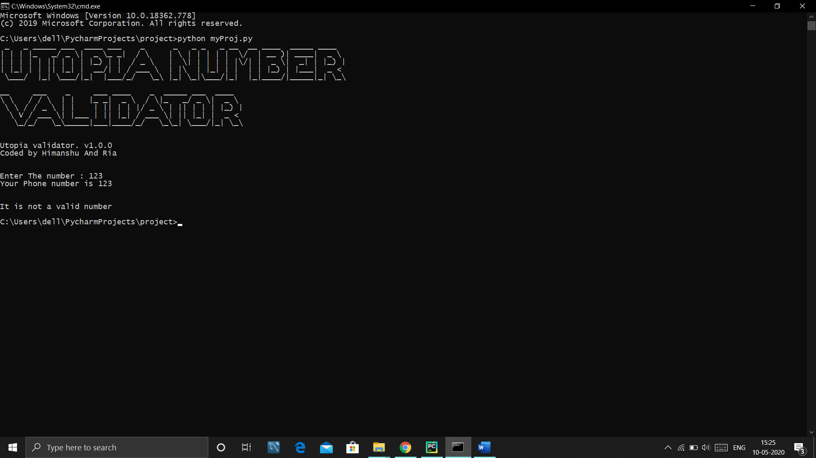

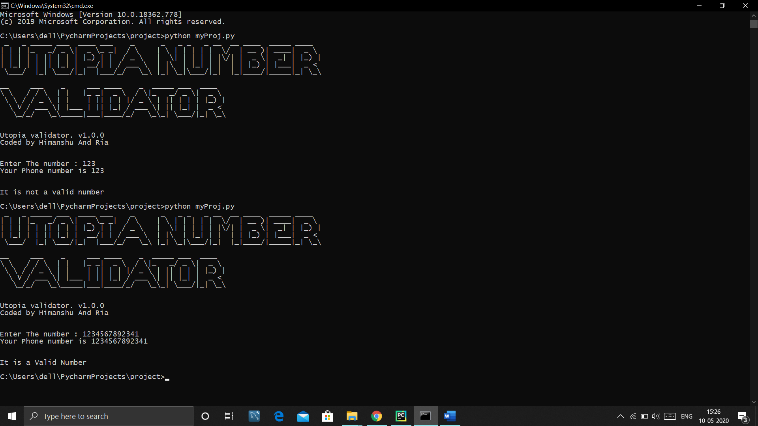

**VIDEO FOR REFERENCE**

**[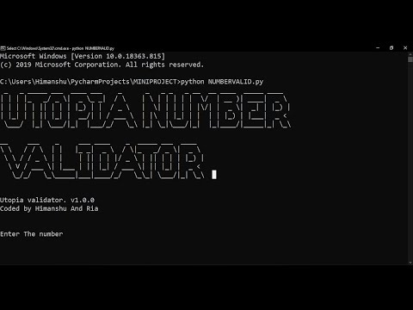](https://www.youtube.com/watch?v=CmeFz5e04h4)**

**IF THIS WILL NOT OPEN THEN THIS IS THE YOUTUBE LINK OF OUR PROJECT**

**https://youtu.be/CmeFz5e04h4**